**Introduction**

Provided is a zip file (BJSS.zip) which contains two projects

1. BJSS.csproj
2. BJSSTests.csproj

Also included in the directory is a Visual Studio solution file.

**Running the code**

The code can be executed either from the Command Line or from Visual Studio Directory. To run from command line, use the “cd” command to navigate to the project directory (BJSS/BJSS) and run the following commands.

1. dotnet build (Figure 1 dotnet build)
2. dotnet run (Figure 2 dotnet run)

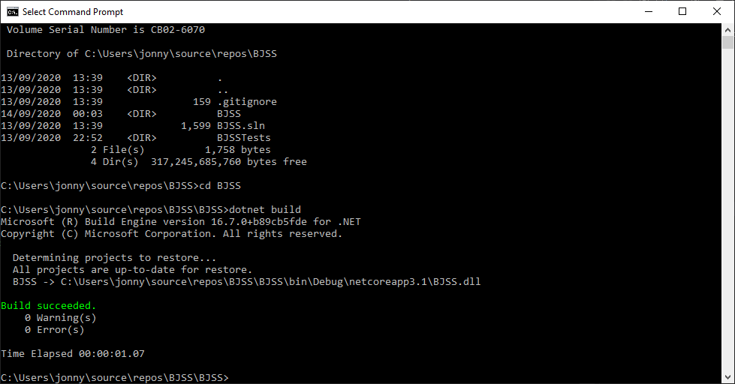

Figure dotnet build

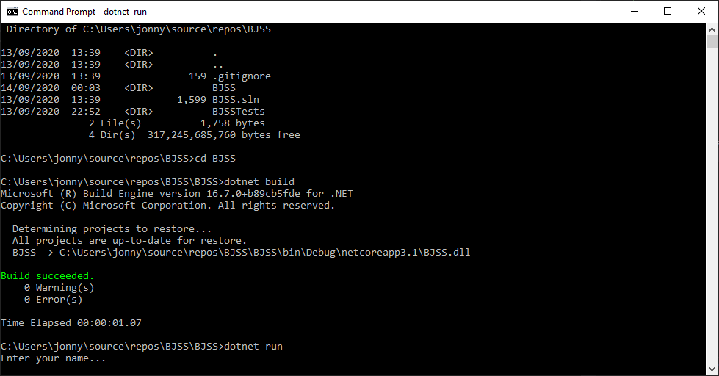

Figure dotnet run

To run from Visual Studio 2019, open visual studio and select “Debug” and choose “Start Debugging”.

**Instructions**

Cards are modelled using their number and house. For example, the seven of hearts is represented as “7H”. The king of hearts would be represented as “KH”

The board is represented as a grid in the console as shown in Figure 3 grid output.

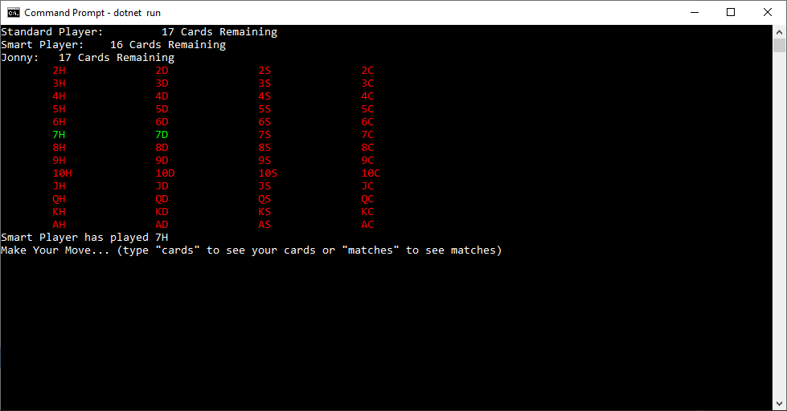

Figure grid output

Typing the “cards” command displays a list of all your cards as shown in Figure 4 cards command

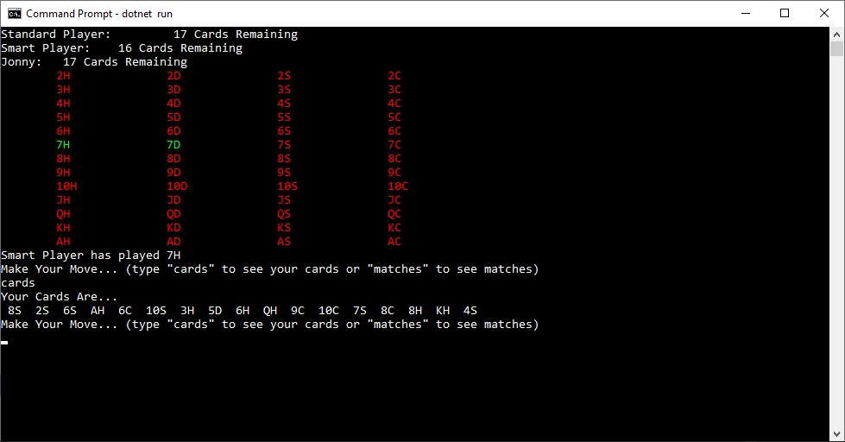

Figure cards command

Typing “matches” shows only cards that are valid to be played in the current state as shown below in Figure 5 matches command

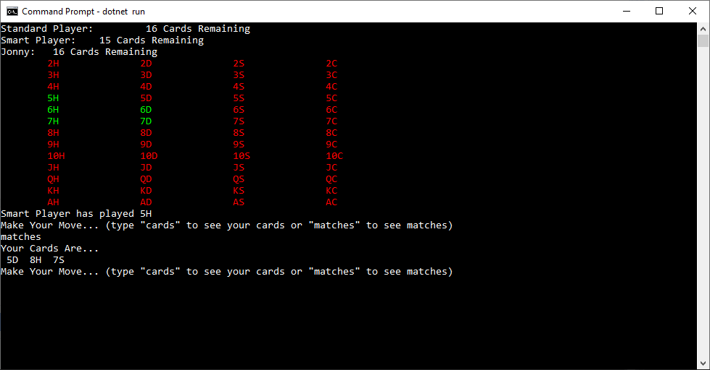

Figure matches command

**Unit Tests**

Unit tests can be run from within visual studio. Right click on the BJSSTests project in the solution explorer and click “Run Tests”.

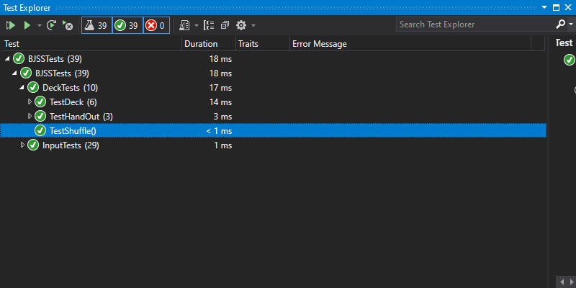

Figure Test results